**FACULTY OF APPLIED INFORMATION TECHNOLOGY**

**Field Of Study: Information Technology**

**Speciality: Programming**

No. of student’s record book:

Akzhan Zhailaubay w67094

**PROJECT**

**Course: Web Technologies**

**Rzeszow 2024**

Contents

Documentation: Homeflix Website 3

Introduction: 3

HTML Structure: 4

CSS code: 9

JS code: 14

Additional Information: 15

End of Documentation 15

# Documentation: Homeflix Website

# Introduction:

The Homeflix website is a responsive website designed to showcase leasing

services for new houses.

It provides information about leasing options, benefits, and features a userfriendly interface.

This documentation provides an overview of the structure and functionality of the HOMEFLIX website. It includes information about the HTML layout, CSS styles, and JavaScript code for tabs interaction and the Swiper slider.

2. HTML Structure

The HTML structure of the HOMEFLIX website includes standard elements such as doctype declaration, head, body, and specific sections for header, main content, and footer. External resources like fonts and stylesheets are linked, and JavaScript libraries are included at the end of the body.

3. CSS Styles

CSS styles for the website are included in the "style.css" file. The styles define the appearance of various elements, ensuring a visually appealing and responsive design. Specific classes like "header," "menu," "slider," and others are utilized to structure and style different sections.

4. JavaScript Interactions

4.1. Tabs Interaction

The tabs interaction is implemented using JavaScript to allow users to switch between different content sections. The code initializes variables for tab items and their corresponding content. The `open` function is triggered on a tab click event, updating the active tab and displaying the associated content.

# HTML Structure:

The HTML structure of the Homeflix website consists of several sections that are carefully

organized to present information effectively and provide an intuitive user experience. The main

sections are described below:

<header>: Represents the header section of the website, containing the logo and navigation

menu. It ensures consistent branding and allows users to easily navigate to different pages of the website.

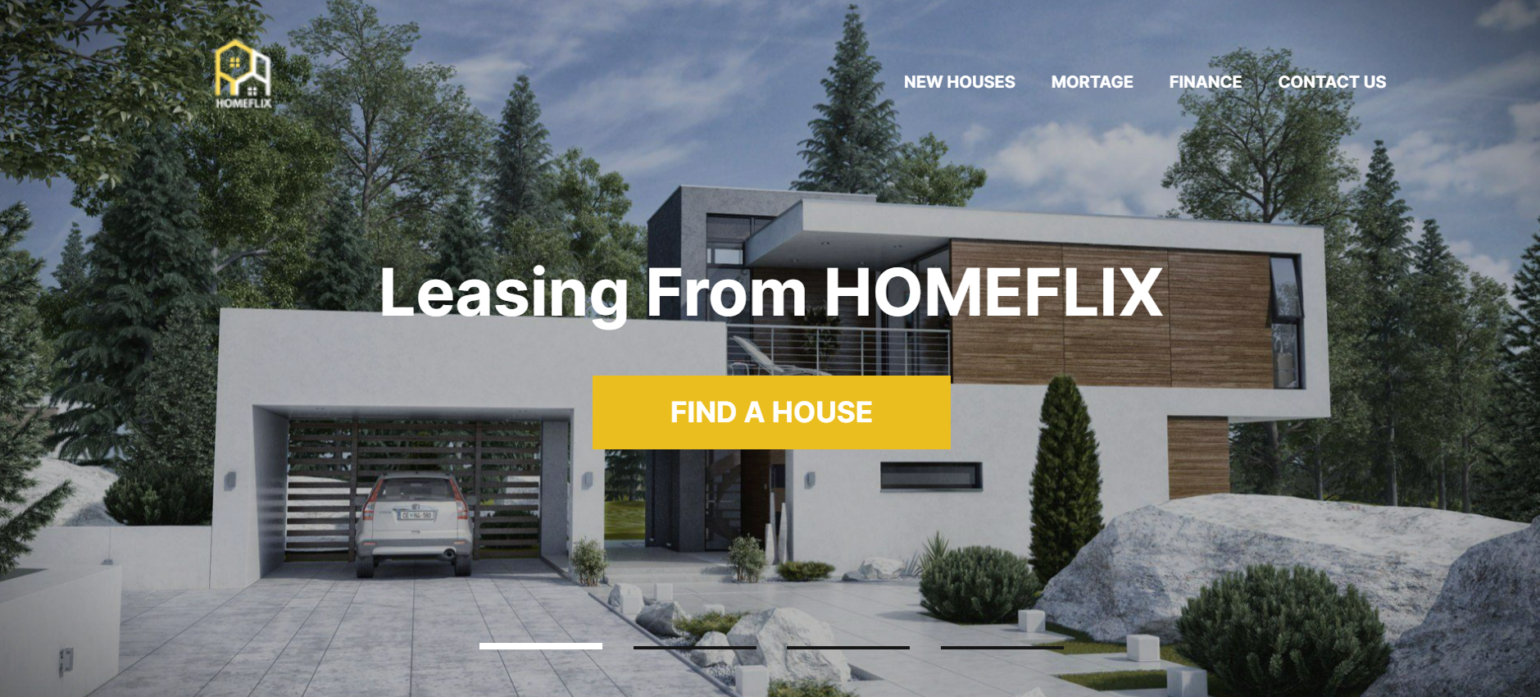

<main>: Contains the main content sections of the website, including the introduction,

slideshow, information on leasing benefits, leasing process, video section, and important factors to consider.

<section class="top">: Displays the introductory section with a call-to-action link,

capturing the attention of visitors and encouraging them to explore further.

<div class="slider">: Includes a slideshow with images using the Swiper library. The

slideshow enhances visual appeal and presents images of different car models available for

leasing.

<section class="why-lease">: Highlights the reasons for leasing with Homeflix,

emphasizing benefits such as lower monthly payments, flexibility, and access to the latest car models.

<section class="how-does">: Provides information on how leasing works, guiding users

through the process and addressing common questions or concerns they may have.

<section class="video">: Displays a video introducing Homeflix, creating a more

engaging and interactive experience for visitors.

Video Section:

Slider Section:

Blog Section:

House Type Section:

# CSS code:

Box Sizing:

Section Title Style:

Wrapper Styles:

Container Styles:

Body Font Styles:

Header Styles:

Menu Styles:

Sales Styles:

Video Styles:

Blog Styles:

# JS code:

Here is the link of github:

<https://github.com/AkzhanZhailaubay/project-web/tree/main/Homeflix>

# Additional Information:

The Homeflix website provides users with additional information and resources.

In the footer section, users can find external links to relevant pages, such as a contact page,

FAQs, and a blog. These links enable users to explore further, find answers to their questions,

and engage with the Homeflix community.

Furthermore, the website includes a video section with an embedded YouTube video, offering

an interactive and dynamic way to learn more about Homeflix and its services.

# End of Documentation

Please note that this documentation provides an overview of the Homeflix website's

structure, functionality, and design choices.

If you have any specific questions or need further assistance, feel free to ask.